**Five-Element Patch Antenna Array**

*Goals of Design*

A design of a patch antenna array consisting of 5-elements will be designed with the intent of measuring and characterizing the device using Colorado State Universities Antenna Test Range. This array is not being designed with the intent of adding it to any device or used in any communication system, it is strictly designed for academic purposes and proof of knowledge. The first goal of this patch antenna is the physical size, it is desired for the final PCB to have dimensions less than , be fed by a total of five SMA connectors with an impedance of Ω, and have a maximum gain greater than .

*What is a five-element patch antenna array?*

A five-element patch antenna array consists of two different ideas, the first being the patch itself and the second comes from lining up *n* amount of these antennas which is called an array. The idea behind how a patch antenna works will be discussed and then the significance of adding them into an array.

First off, a patch antenna works on the same idea behind a normal dipole antenna where an alternating current is fed to it (this current is usually carrying data) and due to the alternating current (which in turn alternates the voltage/charge) will radiate an electromagnetic wave. And this electromagnetic wave carries power outwards from the antenna which can then be received by another antenna. Where a patch antenna differs from a dipole antenna or any antenna is the physical form of it, normally a dipole antenna is a straight wire with some length, or a horn antenna uses a monopole (or multiple) with a metal horn whereas a patch antenna is built with a printed circuit board (PCB) where there is a patch island above a ground plane. And this patch island above the ground plane alternates voltage/charge and generates an electric field. While most of the electric field is located between the patch and ground plane, there is a phenomenon called fringing where the electric field begins to bend out from between the patch and ground plane.

Another important characteristic of different types of antennas is their radiation pattern, and this pattern is unique to the physical shape of the antenna and the frequency at which it operates. However, we will not be going into excruciating detail of how to find these radiation patterns, but it is important to know they exist and have significance. For instance, a normal radiation pattern of a patch antenna is shown in **figure X1** and it simply shows the direction of which the antenna will propagate a wave the best with highest gain (or worse with lowest gain). And if two different patches have the same parameters, as in length and width, they will exhibit the same radiation pattern. But in the case of a patch antenna, it can be seen that it has a very broad radiation pattern which means that it can radiate to a wide angle.

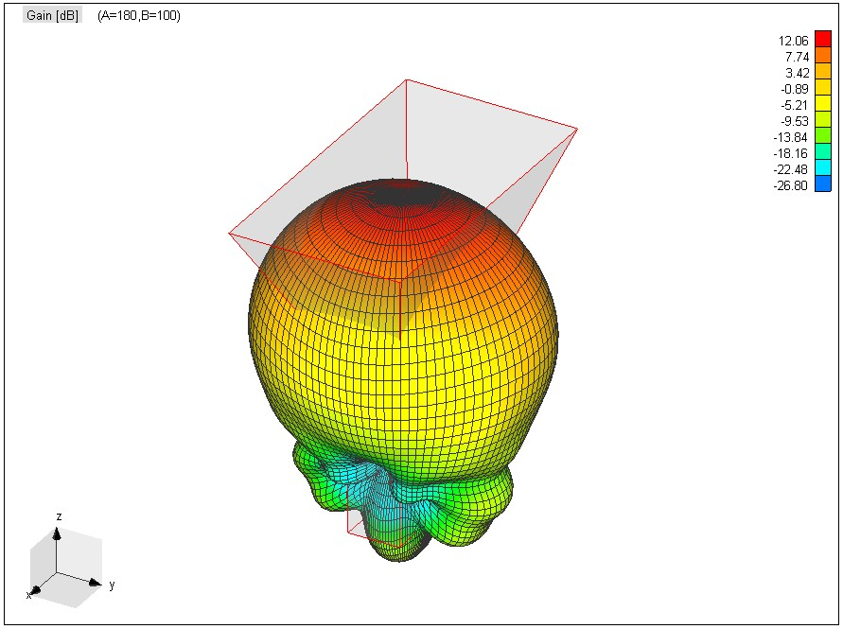

*Figure X1:* Radiation pattern of horn antenna generated in WIPL-D

Secondly, as discussed earlier, each patch will have its own radiation pattern with the patch antenna having a very broad radiation pattern. But what if we want to use patch antennas but have a much more directed main lobe, so as to make it not as broad? Well, that is where putting them into an array can become very useful. Adding antennas in an array can change their radiation pattern by using constructive and destructive interference. Generally, each antenna is placed apart which can give two different base cases depending on the phase of the signal fed into the antenna. In the case which the antennas are fed *in-phase* will result in a main lobe that is normal to the array axis and is called *broad-side*. In the other case, the antennas are fed in *counter-phase* which will result in two main lobes that are parallel to the array axis and is called *end-fire*. By adding more antennas into the array, it will increase the gain of the main lobe (since more antennas are contributing to it) and at the same time make it even more directed. With the use of antenna arrays, a *very* narrow main lobe can be generated, and this can be very useful in many places such as radar and deep space communications. These arrays are not only confined to a single axis, multiple rows and columns can be used and this will allow even more control over the beam. Then add the control of the phase of each the antennas, then you can create something called an electronically controlled phase-array and that allows for the beam to be actively controlled instead of having it at set position.

*Calculating lengths of patch and position of rear-feed line*

Calculating the lengths of the patch antenna are directly related to the wavelength of the operating frequency. In an ideal situation, the length of the patch will be half of the wavelength. However, in the real world the ideal situation is not applicable, so the fringing effect is taken into account, and this will alter the length and width of the patch beyond the half wavelength.

Before any calculations can begin, there are a few constants that need to be defined, such as the dielectric permittivity and resonant frequency. In the case of this patch, the dielectric is selected to be the commonly used FR4 and has a permittivity of (this is an average, typically it ranges between ). The resonant frequency was selected to be , and there are a few reasons this was selected. The main reason is due to the fact that the antenna test range uses a horn antenna as the receiver and it operates in the X-band, so the patch needs to operate in the same frequency band. The second reason is since the size of the patch and patch separation is directly related to the wavelength, a lower frequency (larger wavelength) would result in a larger patch, and the patch was desired to be small. The last constant that needs to be defined is the height of the dielectric, this height is determined by the standard height of PCBs. The preselected company of choice that this antenna will be manufactured by is Advanced Circuits located in Aurora, CO. The standard two-layer PCBs have a height of .

The first of the patch is found using [4]:

Before finding the length, the effective permittivity needs to be found. This effective permittivity comes from the fringing effect since some of the electric field will be in air and some inside the dielectric. The effective permittivity is found using [4]:

Now that the width and effective permittivity has been found, the length needs to be calculated. The length will have two parts, the first part is the main length (), but since fringing is taken into effect, an additional length () needs to be added. The length of the patch is found using [4]:

Finally, the feed point () of the patch antenna needs to be found. Also note that since the patch will be fed using a Ω SMA, the input impedance will also be Ω. The feed point can be found using [4]:

Where: is the wave number

is the input impedance ~ Ω

is a Bessel function of the first kind of zero order

The last thing to do is to find the minimum size of the ground plane that needs to lie under the patch on the PCB. But this is generally or .

With and the ground plane found dimensions, the design of the patch is now complete.

*Simulation of patch antenna*

With the initial dimensions of the patch found, it is time to throw them into simulation software to see the radiation pattern of the individual patch. The software that was selected to simulate the patch (and later the array) was WIPL-D, which is a software program that is excellent for simulating radiated antenna fields. In fact, the advisor of the CSU ATR, Branislav Notaros, was on the development team for the software.

It is important to note that the patch is simulated on a finite ground plane and not an infinite one because when it comes to the edges of the plane, they are within a close enough distance that infinite cannot be assumed. This patch can be seen in figure **X2** where the red signifies the dielectric and the teal signifies the conductor, or patch. In the center of the patch, it can be seen that voltage generator is located to the right of the origin, this signifies the feedline of the patch. The frequency of the input for the simulated radiation was at and the radiation pattern can be seen in figure **X3**.

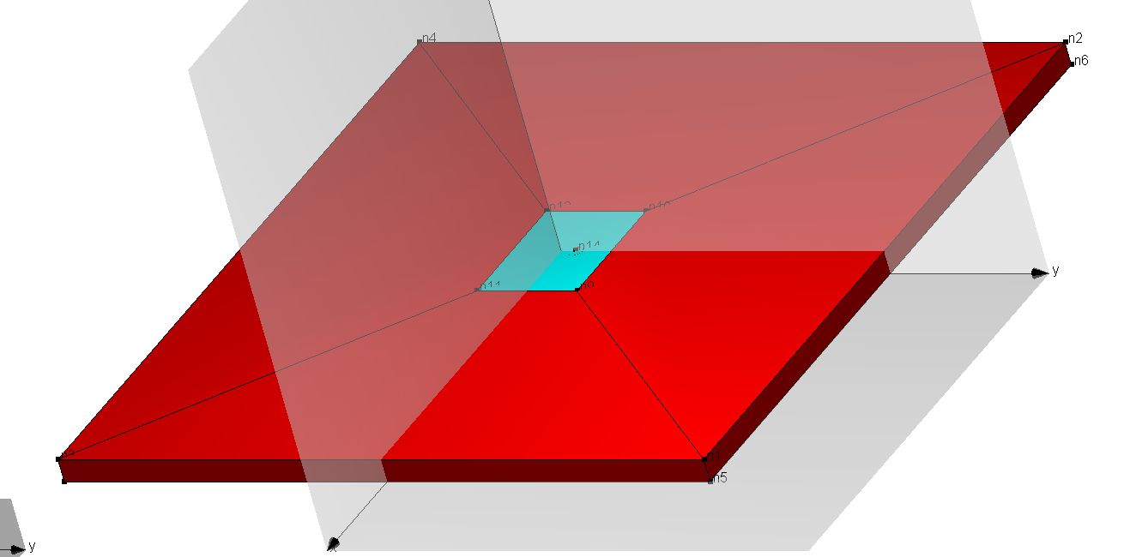

*Figure X2:* Individual patch antenna model in WIPL-D

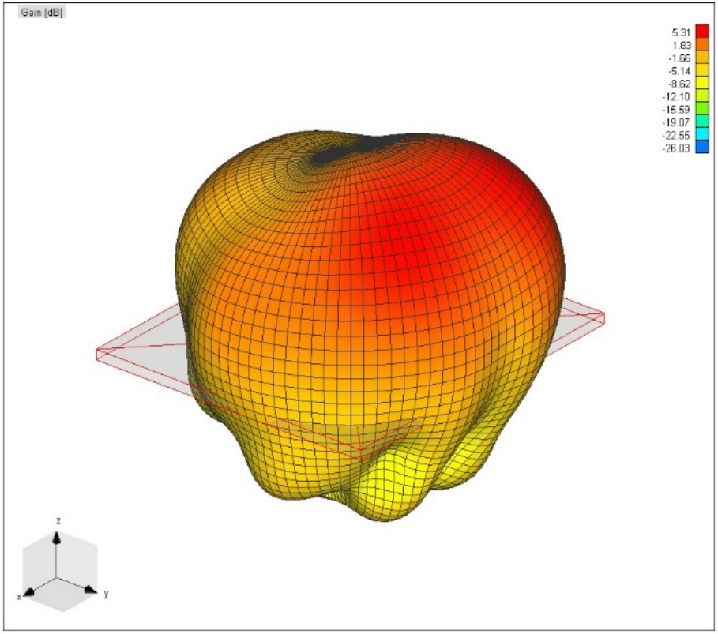

*Figure X3:* Radiation pattern of patch antenna

The radiation pattern has a good general shape which has a wide higher gain region normal to the patch radiates with a higher gain. The individual patch has a peak gain of which is slightly lower the typical patch antenna, but it is still acceptable in terms of this project.

Now that the individual patch has been simulated and produced acceptable results in terms of the radiation pattern and gain, it is time to move onto simulating the patch in a 5-element array.

*Simulation of 5-element patch antenna array*

The software to simulate the 5-element patch antenna array is still WIPL-D and all the meanings of the colors have remained the same. It is important to note again that the separation between the edges of the patches is and this is allowing the array to have a broadside radiation, in other words the radiation will have a maximum gain normal to the ground plane. Two key characteristics of throwing the patches into an array is that the radiation pattern will become more directed and maximum gain of the main lobe will increase.

Before 5 elements were tested, a 3-element array was created just to see how the array radiates and if two things happen. First, if the general shape of the radiation pattern becomes more directed and if the gain of the main lobe increases. The 3-element array can be seen in figure **X4** and the radiation pattern in figure **X5**.

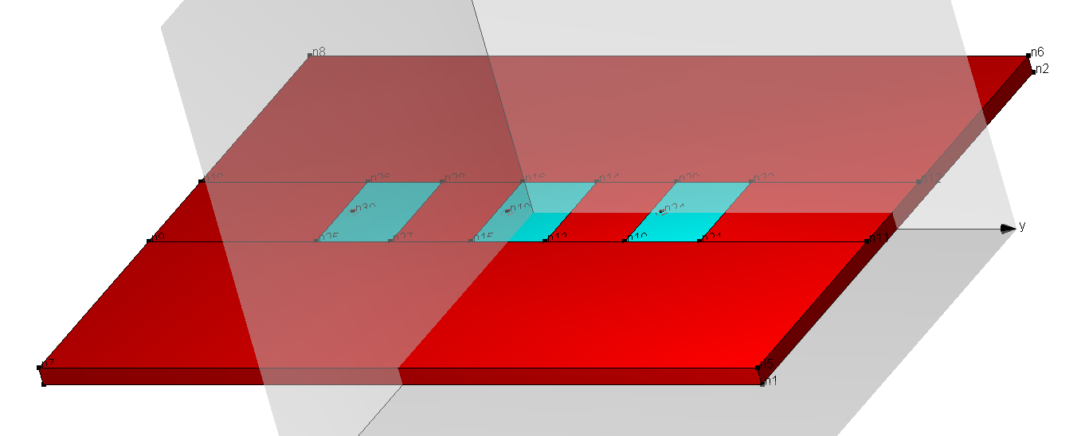*Figure X4:* 3-Element patch antenna array model

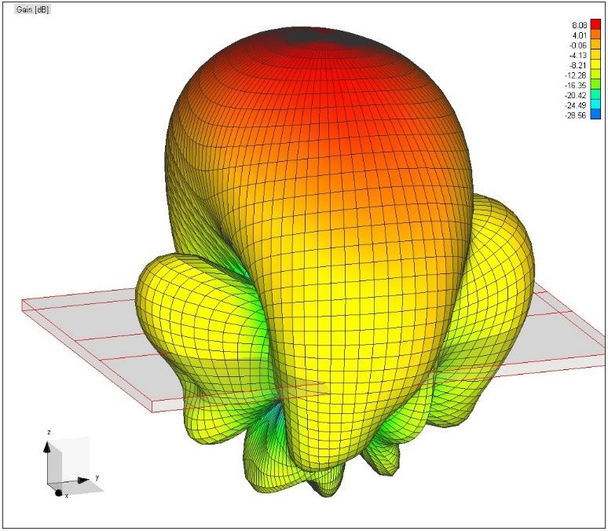

*Figure X5:* Radiation pattern of 3-Element patch antenna array

The radiation pattern shows the two trends that is desired, with both the radiation pattern becoming more directed to the broadside and the gain has now increased to . Since this trend is desired, it was acceptable to add the final two patches for the desired 5 elements. The 5-element patch array can be seen in figure **X6** with its radiation pattern shown in figure **X7** and **X8**.

*Figure X6:* 5-Element patch antenna array model 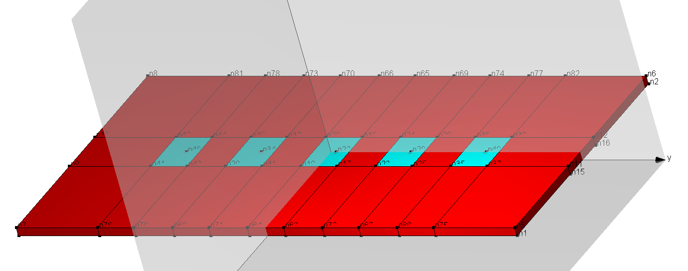

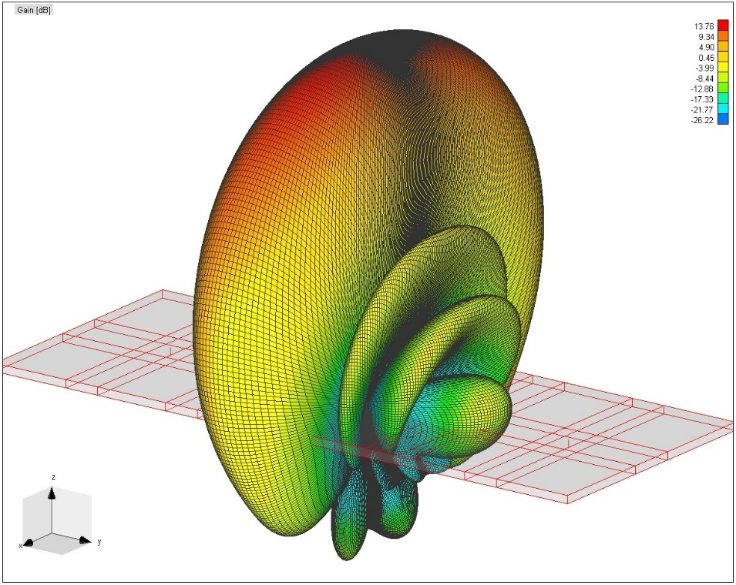

*Figure X7: 3-D* Radiation pattern of 5-Element patch antenna array

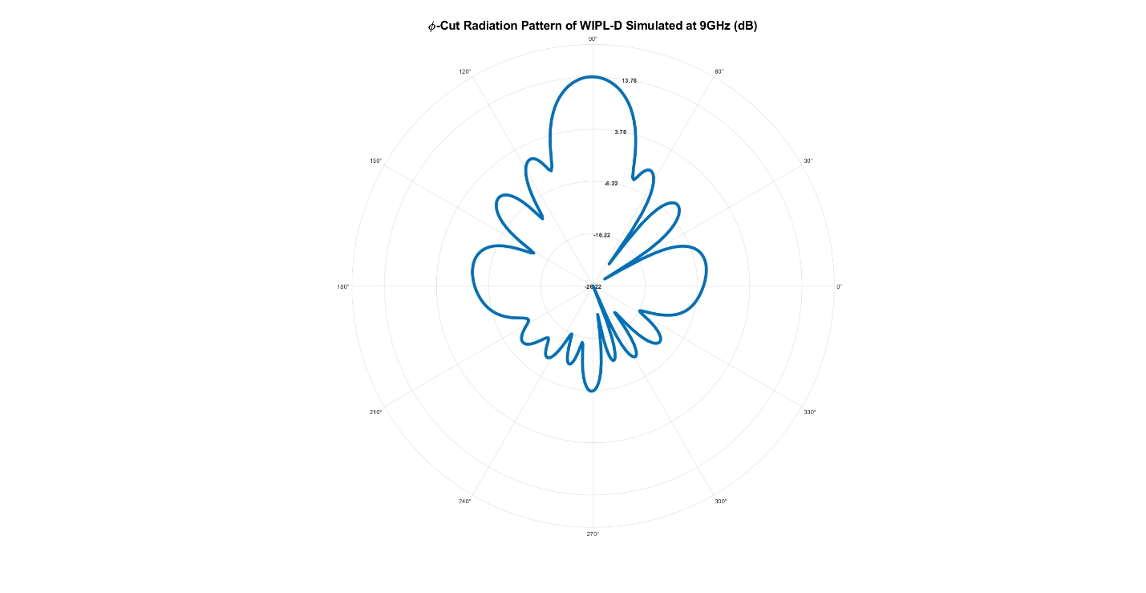*Figure X8: -c*ut Radiation pattern of 5-Element patch antenna array

The maximum gain has increased all the way to which has exceeded the goal of and the main lobe has become very directed with a few side lobes. These side lobes are not as desired, but they are hard to avoid when adding them into an array. But nonetheless, the simulated radiation pattern for the 5 elements is acceptable and therefore the design to produce the patch antenna can begin.

*Generating Gerber Files for PCB*

Now that simulation of the patch antenna array is complete and showing adequate results, it is time to move onto the manufacturing of the patch antenna array. The software used to design the PCB was KiCad and it was decided to run the feedlines on the same plane as the ground plane and this was to mitigate the crosstalk between the lines. Another important design parameter is the trace that connects the SMA to the via was designed to have an impedance of 50Ω to continue to match all the impedances. The overall design process of the PCB was simple as the whole array has already been designed and it was a matter of just getting it replicated in KiCad to be sent to some manufacturer. The PCB can be seen in figure **X9**. The PCB had the specifications that the dielectric is FR-4, two layers, and it is ~. The manufacturer that was selected was Advanced Circuits since they were a local company and had been recommended by various engineers.

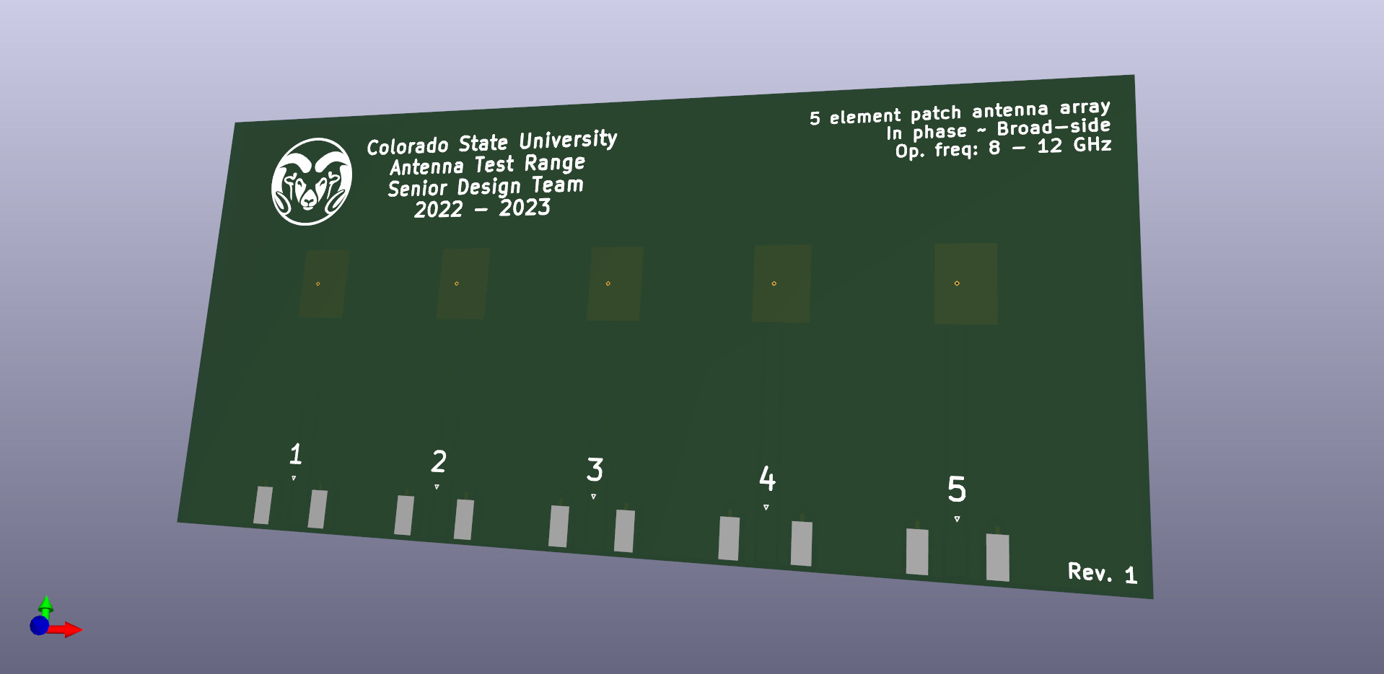*Figure X9:* PCB Design of 5-element patch antenna array in KiCad

*Antenna Test Range Measurements*

With the antenna in hand, some additional work with the mechanical engineers on the team needed to be done to get a mount for the patch antenna (which was discussed in previous sections). And after the mount was created, the antenna was able to be put into the range and measurements made.

The geometry that was measured was a sweep of the azimuth direction, this was done because it shows the most nulls and lobes, seen above in figure **X8**. The method of measuring the antenna consisted of making 5 separate measurements, which meant hooking up each the coaxial cable to each port on the patch antenna and making a measurement of the single patch. Each scan of each patch was done from 7GHz to 13GHz to cover the entire X-band and little bit more. Once the 5 measurements were made, they were exported and by using Matlab, the 5 fields were all superposed on top of one another. This is perfectly okay to do instead of taking a single measurement with all 5 patches fed at the same time as superposing the individual fields on top of each other is identical.

Looking below at figure **X11**, which is one of the 5 separate patch measurements, it can be seen to have a broad main lobe with two smaller lobes. And then figure **X12** shows the total radiation pattern (red line) of all 5 elements superposed on top of each other and the simulated field from WIPL-D layered on top to help compare both fields. Looking at the nulls between both of them, they both line up in the same spots and both resemble each other which is a great sign and gives enough proof to affirm that the patch antenna array is a success and met the objectives.

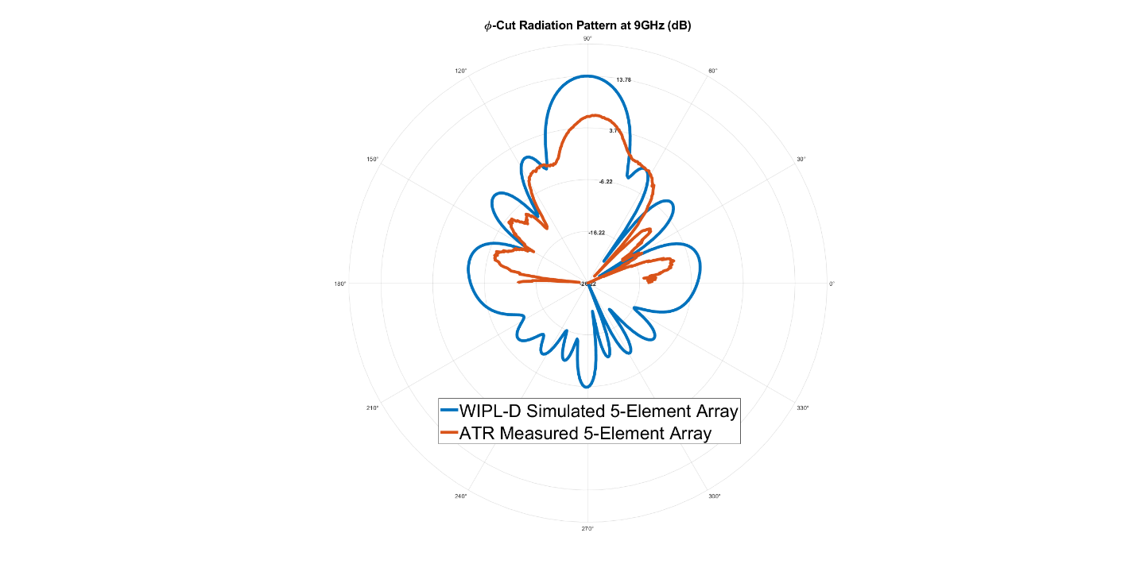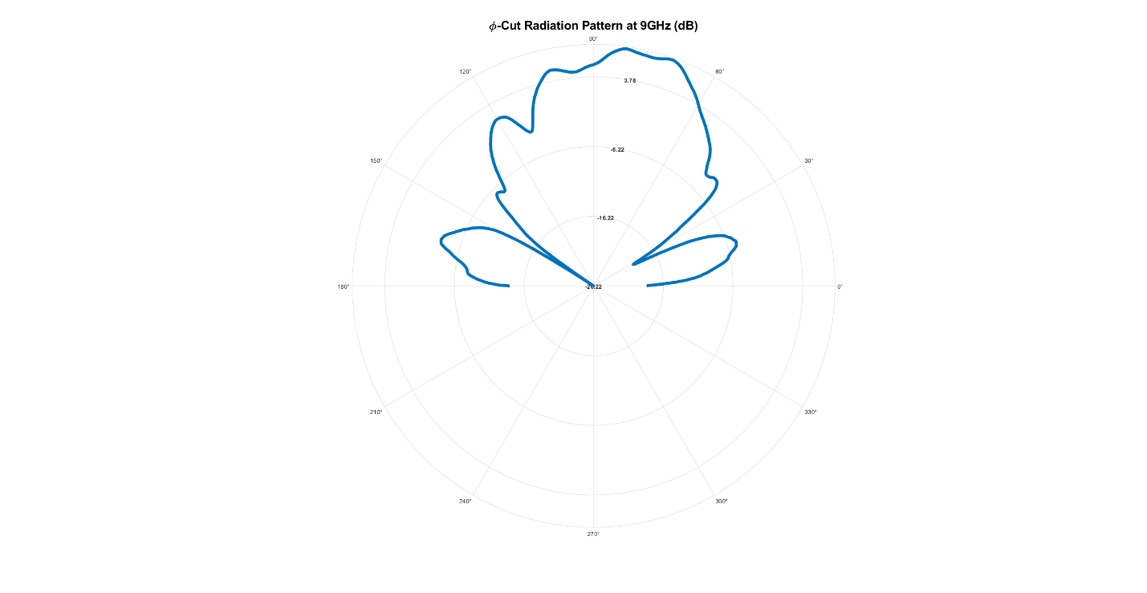*Figure X10:* Radiation pattern of individual patch of element 3 (middle element)

*Figure X11:* Radiation pattern of both simulated (blue) and ATR measured (red) 5-element patch antenna array

*Wrapping It All Up*

The end goal of designing the antenna had two objectives, to gain experience designing and testing an antenna, but to also use the antenna test range for what it is used for. The process of initially designing the antenna with different specifications gave insight into what all needs to be thought about before the design process can begin. Such as the material that will be used, height of the dielectric (since the height can change the radiation pattern), the phase which the patches will be fed, and even how the feedline will supply the antenna. Moving onto the simulation, there are many different parameters that need to be accounted for and what about the radiation pattern is desired and what is deemed good or bad. And working in KiCad, it also was a whole process with the vias, traces, and planes. It was very important to know which conductors are connected to which ones and that it would not be good to connect the feed trace to the ground plane. And finally with getting the measured fields from the antenna test range, it took knowledge of electromagnetics to know that each patch can be measured and then superposed on top of each other to get the total radiation pattern.

There is some discrepancy between the simulated and measured radiation pattern, and these can stem from a few things. The first being that the simulation works with ideal conditions such as perfect electric conductors and no losses. A big difference between the simulation and the real PCB is that in WIPL-D, the traces could not be considered and that the generators were connected directly to the patch where the via’s are located. This would eliminate any possible crosstalk. Another consideration is from human error and when the measurements are being taken, they are of each individual patch so the whole scan needs to be reset each time. And there is a chance that the location of each can is not at the exact same location and that instead of superposing a single point, it is superposing a small area where 5 different elements were scanned. Both could lead to discrepancies between the simulated and measured radiation pattern. But again, they both resemble each other very closely with the nulls lining up perfectly except the two in the main lobe.